PROJECT 1

Penetration Testing on webapplication:"testphp.vulnweb.com"

October 9, 2024

soumyadip saha

Email- soumyadipsaha743@gmail.com

Phone- 7063155948

# Table of Content

1.Abstract

2.Introduction

3.Scope Of Work

4.Tools and Frameworks utilized

5.Techniques and Methodologies Used

6.Vuluerabilities Identified and Proof of Concept

7.Recommentations

8.Challenges

9.Conclution

10.References

1.Abstract:

SQL injection is considered one of the most dangerous threats to websites and also databases, such vulnerability enabling the attacker to access the web and the databases. As it accesses databases it might change, steal the data, or destroy the database utterly. Currently, and with the implementation of sqlmap found in the literature being scarce and limited, SQL injection detection tools and methods are used without any detailed analysis of their strength and weakness. This paper demonstrated different types of SQL injection with an example, also we know how to detect the SQL injection, the paper shows the important tools that enable the detection of dangerous attacks to prevent the SQL injection and compares them according to the important performance parameter measures. Finally, with the implementation adopted on an ethical and legal website, the proposed paper implemented the most important tool which is called sqlmap . The implementation results reveal access to the database and extract the username and password.

Keywords:

SQL Injection, SQLMap, SQL Tools, Blind Injection, Website Vulnerabilities.

**2.Introduction**

**Overview:**

The purpose of this penetration test is to evaluate the security of the web application “testphp.vulnweb.com” by identifying vulnerabilities that may expose the application to cyber threats. This report provides an overview of the methodologies used, proof of concept (POC) for identified vulnerabilities, tools utilized during the testing, and recommendations for remediation.

**Objective:**

The identified vulnerabilities in the web application hosted at “testphp.vulnweb.com” through ethical penetration testing, using appropriate tools and techniques. This report includes techniques used, tools and frameworks utilized, and proof of concept (POC) screenshots demonstrating identified vulnerabilities.

**3. Scope of Work**

The scope of this penetration test covers the following:

* Web application vulnerability assessment on "testphp.vulnweb.com"
* Identification of potential risks associated with user inputs, session management, and data storage
* Focus on OWASP Top 10 vulnerabilities, including SQL Injection, Cross-Site Scripting (XSS), and Cross-Site Request Forgery (CSRF)

**4. Tools and Frameworks Utilized**

The following tools and frameworks were employed during the testing phase:

* **Burp Suite**: Intercepting proxy for HTTP/S requests, used for manual and automated scanning.
* **SQLmap**: Automated SQL injection tool for detecting and exploiting SQL injection flaws.
* **OWASP ZAP**: Vulnerability scanning tool used to identify common vulnerabilities.
* **Nikto**: Web server scanner to discover known vulnerabilities.
* **Hydra**: Used for brute-force testing of login credentials.
* **Nmap**: Network discovery and security auditing tool for mapping open ports and services.
* **Metasploit Framework**: Exploit development and post-exploitation tool used to validate critical vulnerabilities.

**5. Techniques and Methodologies Used**

During the penetration test, the following techniques were employed:

* **Reconnaissance**:
  + Gathered information about the target using tools like Nmap to discover open ports and services.
  + Used Whois and NSLookup for domain and IP address lookups.
* **Vulnerability Scanning**:
  + Conducted an automated vulnerability scan using OWASP ZAP to identify potential attack vectors such as XSS and CSRF.
* **SQL Injection (SQLi)**:
  + Utilized SQLmap to test for SQL injection vulnerabilities in the web application by targeting input fields that handle user input, such as login forms.
* **Cross-Site Scripting (XSS)**:
  + Tested user input fields, search boxes, and comment sections for improper sanitization of input data. Executed a series of payloads to determine whether malicious scripts could be injected.
* **Session Management Testing**:
  + Evaluated session cookie security, identified weak session management practices, and attempted session hijacking using Burp Suite.
* **Brute-Force Attacks**:
  + Attempted login brute-force attacks using Hydra to determine whether the login form was vulnerable to credential stuffing or weak password enforcement.

**6. Vulnerabilities Identified and Proof of Concept**

**5.1. SQL Injection (SQLi) Vulnerability**

**Description**: The login form was found to be vulnerable to SQL Injection, allowing an attacker to bypass authentication and access restricted areas.

**Proof of Concept**:

* **Tool Used**: SQLmap
* **Payload**: admin' OR 1=1--
* **Result**: Successfully logged in as admin without valid credentials
* **Screenshot**: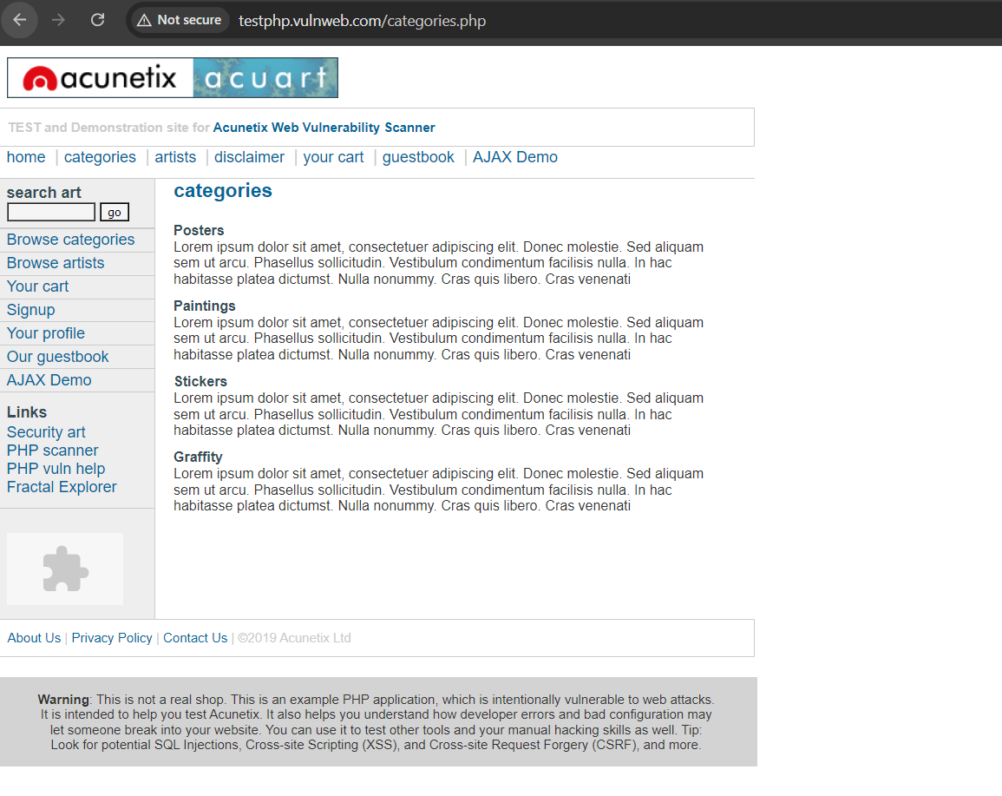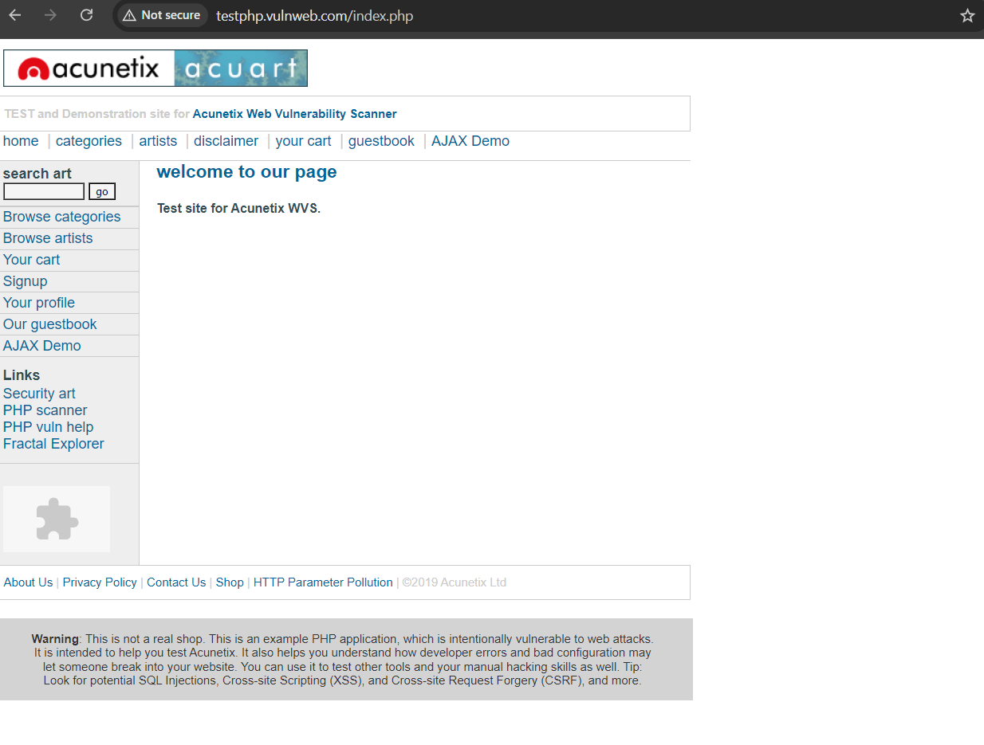

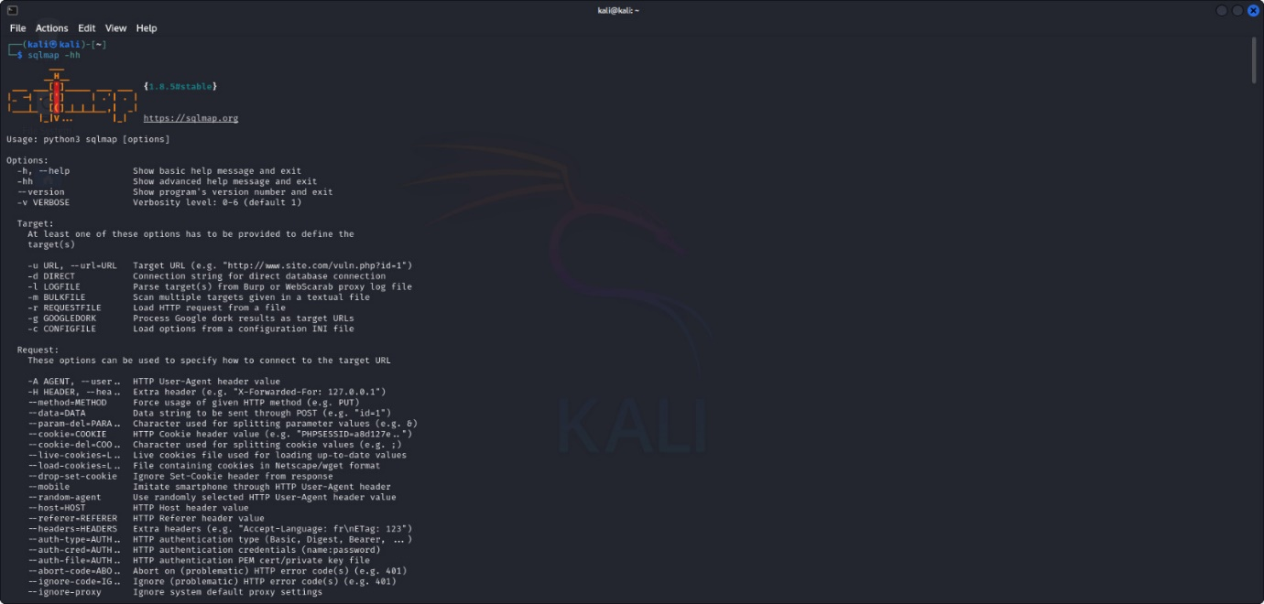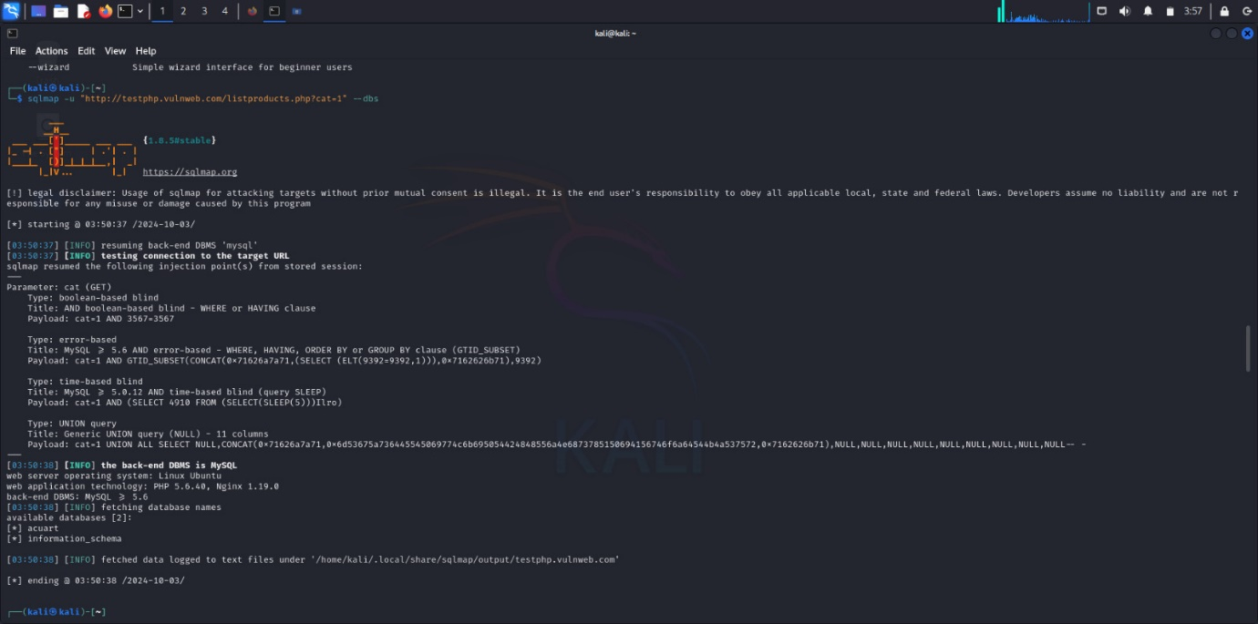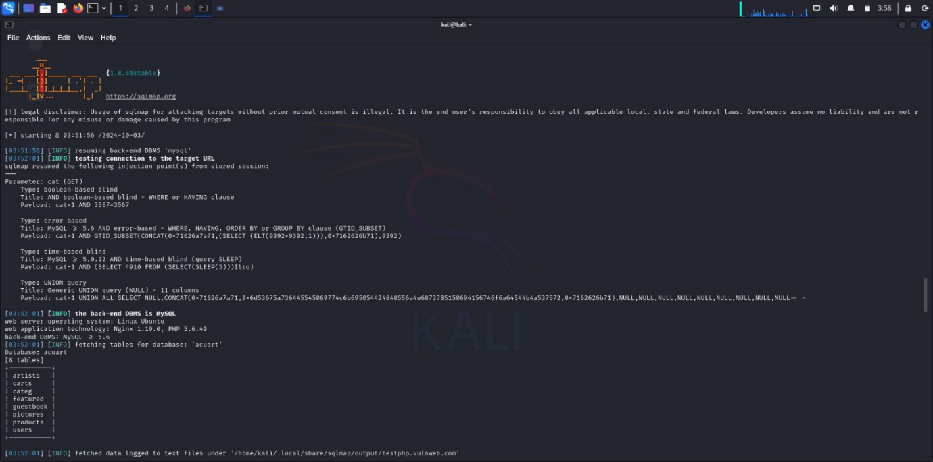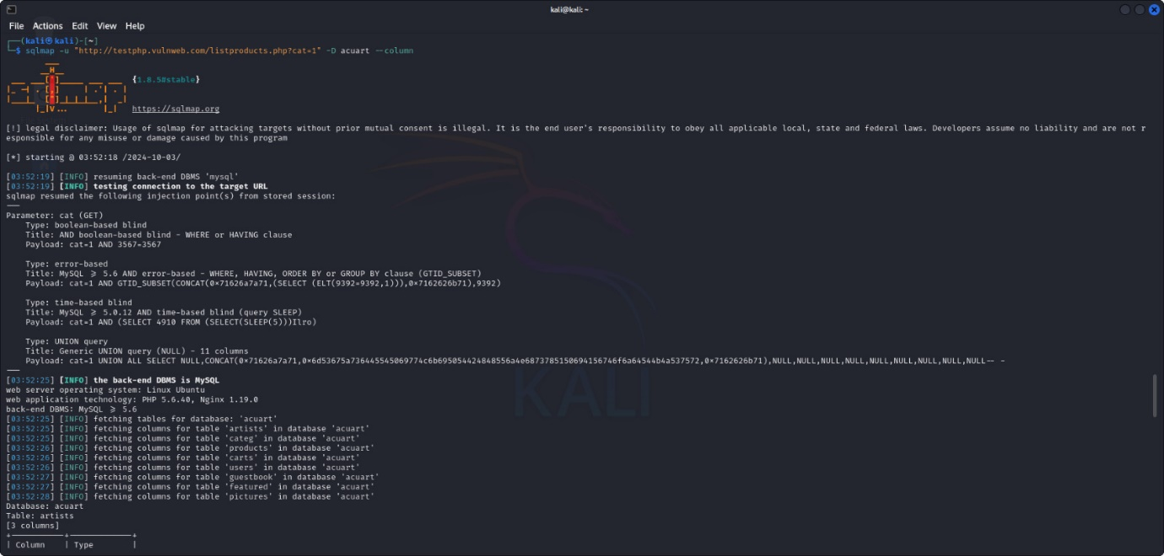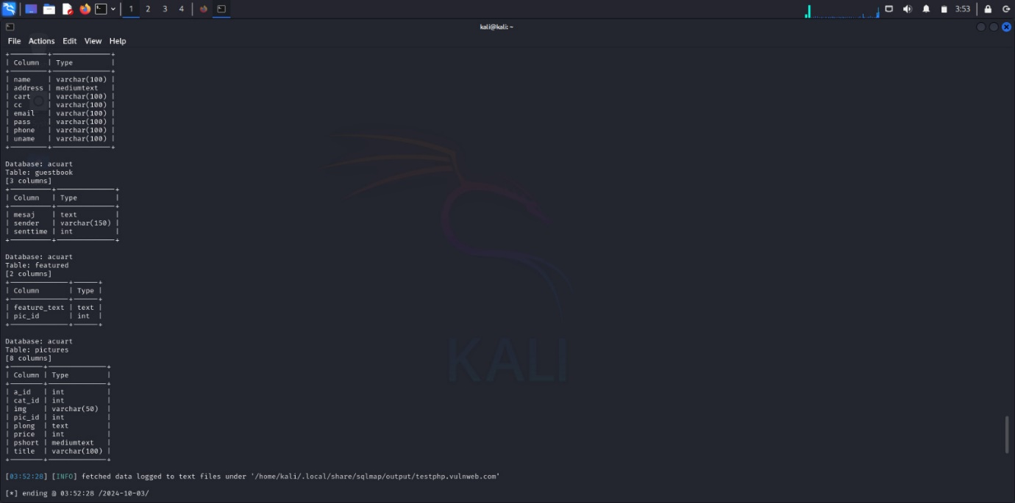

**5.2. Cross-Site Scripting (XSS)**

**Description**: The comment field on the product review page was vulnerable to reflected XSS, allowing an attacker to inject JavaScript that could execute in other users’ browsers.

**Proof of Concept**:

* **Payload**: <script>alert('XSS')</script>
* **Result**: Script executed successfully on page load, displaying an alert.

**5.3. Weak Session Management**

**Description**: Sessions were found to be vulnerable to hijacking due to lack of secure flags in cookies and improper session expiration.

**Proof of Concept**:

* Used Burp Suite to intercept and replay session cookies, successfully hijacking a user’s session.

7. Recommendations

**6.1 SQL Injection**

* **Mitigation**: Use prepared statements and parameterized queries to avoid SQL injection.
* **Additional Advice**: Regularly test all input fields for SQL injection vulnerabilities.

**6.2 Cross-Site Scripting (XSS)**

* **Mitigation**: Implement input validation and sanitization to remove malicious code from user inputs.
* **Additional Advice**: Use Content Security Policy (CSP) to limit the impact of injected scripts.

**6.3 Cross-Site Request Forgery (CSRF)**

* **Mitigation**: Implement anti-CSRF tokens to protect forms from unwanted submissions.
* **Additional Advice**: Use HTTP headers to ensure forms are submitted only from trusted origins.

8. Challenges

To protect it from SQL injection, which is considered a major threat as it makes many threats such as deceiving people that the website is the real one but it is not, changing prices, changing data in databases or even destroying them, reaching the highest validity of the admin, canceling access to Server, or access to important financial and confidential information, prevent important processes from running and modify existing records. Several challenges exist and the security team should consider them before taking a decision:

**1.** SQL tools are scattered without complete real implementation in a practical case study. So, the proposed paper implements SQLMAP tool and generates the username and password for legal and ethical websites. Therefore, the selection of the best tool in regard to a specific problem, by make a comparison between the current tools.

**2.** Increase the experience of security manager depends on understanding the SQL injection types taxonomy. The paper provides a detailed analysis and experimental results of different

Scenarios.

**9.Conclusion**

The penetration test of “testphp.vulnweb.com”, several vulnerabilities were identified, including SQL injection and potential XSS vulnerabilities. These were demonstrated using various tools such as Burp Suite, SQLmap, and Nikto. Screenshots included show proof of concept for these vulnerabilities .It is recommended that the development team implement proper input validation, apply security patches to the server, and enhance the overall security posture to mitigate these risks.

10.References

[1]. Tahir, F., A. Mitrovic, and V. Sotardi, Investigating the causal relationships between badges and learning outcomes in SQL-Tutor Research and Practice in Technology Enhanced Learning, 2022. 17(1): p. 7.

[2]. Falor, A., et al. A Deep Learning Approach for Detection of SQL Injection Attacks Using Convolutional Neural Networks. in Proceedings of Data Analytics and Management. 2022. Singapore: Springer Singapore.

[3]. Shah, A., et al., Blood Bank Management and Inventory Control Database Management System. Procedia Computer Science, 2022. 198: p. 404-409.

[4]. Nouby M. Ghazaly, A. H. H. . (2022). A Review of Using Natural Gas in Internal Combustion Engines.International Journal on Recent Technologies in Mechanical and Electrical Engineering, 9(2), 07–12.

<https://doi.org/10.17762/ijrmee.v9i2.365>

# PROJECT 2

# Network scanning and network penetration test

**Table Of Content**

1.Abstract

2.Objective

3.Introduction

4.Scope Of Work

5.Tools and Framework Used

6.Testing Techniques

7.Result and Findings

8.Non-Technical Summery

9.Recommended Action

10.Colclution

**1. Abstract**

**The goal of this network penetration test was to identify potential vulnerabilities within the company's virtual machines (Windows VM and Ubuntu VM) and suggest remediation to enhance their security. By performing a thorough network scan and penetration testing, we aimed to discover open ports, running services, and any known vulnerabilities that could be exploited by malicious actors. The focus was on ensuring that the identified vulnerabilities were addressed to protect the network and maintain the integrity of the systems.**

**2.Objective**

**Identify devices on the network and assess vulnerabilities in Windows and Ubuntu virtual machines**

**3.Introduction**

This penetration testing report offers a complete security posture assessment of the target system, network or application as contracted. The penetration test was conducted to discover vulnerabilities and potential impact and to provide recommendations for mitigating the identified risk. This report seeks to highlight weaknesses in security controls, and to measure the effectiveness of the defensive mechanisms already in place by simulating real world attack scenarios.

Industry standard testing methodologies such as Pen-Test tools,

Nmap, Metasploit were enforced, and tests were performed. The coverage and accuracy were ensured by both automated tools and manual techniques. This report describes scope of engagement, testing methodology, vulnerability findings and risk assessment for findings.

The discovered vulnerabilities are grouped according to their severity (critical, high, medium and low), and recommendations are made to mitigate the risks by addressing these vulnerabilities to maximize system security.

Using pentest-tools.com

I used this automated tool to scan the website for some basic information. The scan provided me with

Server software and technologies, Open ports discover DNS Records and IP Information.

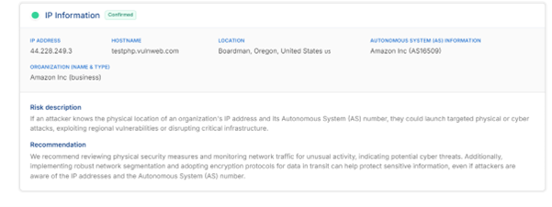

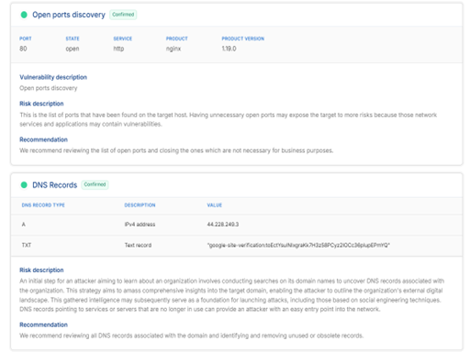

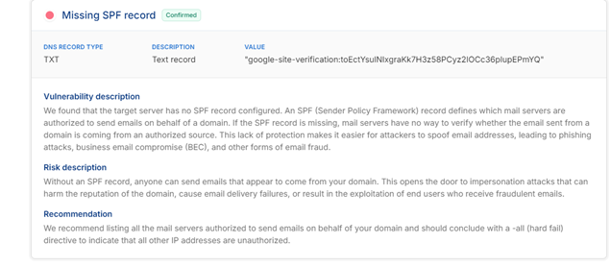

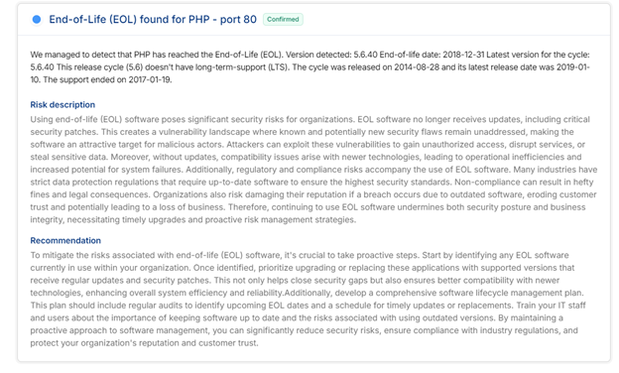

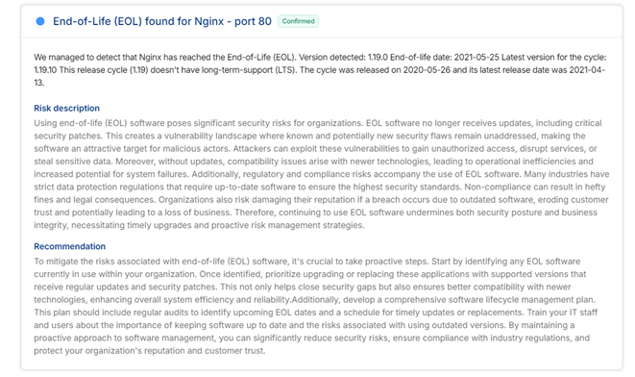

**4. Scope of Work**

The penetration test focused on the following:

* Scanning for active devices (Windows and Ubuntu VMs) in the network
* Identifying open ports and running services on the VMs
* Vulnerability scanning to identify outdated software or misconfigurations
* Exploitation attempts on any identified vulnerabilities

**5 .Tools and Frameworks Utilized**

The following tools were used to perform network scanning and vulnerability detection:

* **Nmap**: For network discovery and port scanning.
* **OpenVAS**: An open-source vulnerability scanner used for identifying known vulnerabilities.
* **Metasploit Framework**: For exploitation of vulnerabilities found.
* **Wireshark**: For network traffic analysis and packet capturing.

**6.Testing Techniques**

The following testing techniques were used during this assessment:

* Network Discovery:
  + Used **Nmap** to identify active devices on the network and the services they were running.
* Port Scanning:
  + Nmap scans were conducted to identify open ports, helping us understand the services and potential entry points to both the Windows and Ubuntu VMs.
* Vulnerability Scanning:
  + **OpenVAS** was employed to scan both the Windows and Ubuntu VMs for known vulnerabilities such as outdated software or weak configurations.
* Exploitation:
  + Used **Metasploit** to attempt exploitation of identified vulnerabilities to confirm their validity and potential impact.

**7.Result and Findings**

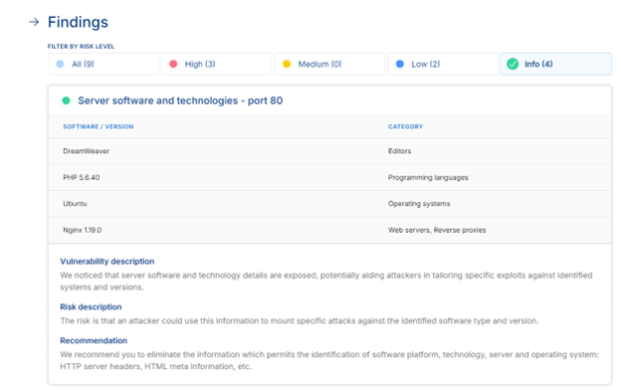

Then we used the scan to find the vulnerabilities: -

**1.High risks: -**

a. Vulnerabilities found for PHP 5.6.40 - port 80: -

**CVE-2022-4577 (CVSS 9.8):** Issue: On Windows, before PHP 8.2.8, an attacker could pass unauthorized options to PHP binary with improper handling of certain command line options.

Impact: With this, an attacker could show the source of scripts or even run arbitrary PHP code.

**CVE-2017-8923 (CVSS 7.5):** Issue: In PHP zend_string_extend fails to handle long strings correctly, this can result in the crashing of the application.

Impact: Thus, an attacker could crash the system or run malicious scripts.

**CVE-2017-9225 (CVSS 7.5):** Issue: The out of bounds writing during regular expression compilation is caused by a buffer overflow vulnerability in Oniguruma which PHP uses.

Impact: Memory corruption can occur because of this, and if successful will allow attacker to execute arbitrary code.

**CVE-2019-9641 (CVSS 7.5):** Issue: A vulnerability in PHP’s EXIF component for image file handling can result in memory errors.

Impact: It means that we will run into situations where attackers can open a door to do something arbitrary or crash our application.

**CVE-2015-9253 (CVSS 6.8):** Issue: The php-fpm master process in older PHP versions can run in a never-ending cycle and consume all CPU resources.

Impact: The server will be subjected to a denial of service (DoS) attack since log files are being written to the server to the point where no other operations can take place.

Each vulnerability can give attackers the ability either to disrupt services or to gain unauthorized access to the system. To correct the issues with PHP, the recommendation is to upgrade to a newer PHP version.

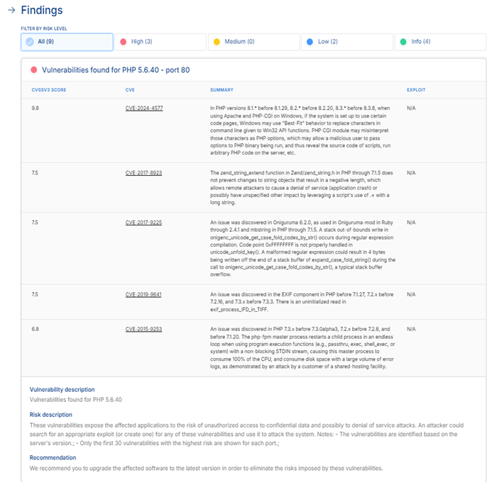

**B. Vulnerabilities found for Nginx 1.19.0 - port 80: -**

**CVE-2022-41741 (CVSS 7.8):** Issue: NGINX before 1.23.2 could corrupt worker memory with an audio/video file of a specially crafted format, resulting in an out of bounds write vulnerability.

Impact: The services or memory disclosure could be terminated.

**CVE-2023-44487 (CVSS 7.5):** Issue: An attacker can abuse request cancellation to perform a denial of service (DoS) vulnerability in the HTTP/2 protocol.

Impact: That can result in excessive resource consumption of the server.

**CVE-2022-41742 (CVSS 7.1):** Issue: This one too could crash the worker process, or leak memory, unlike CVE-2022-41741.

Impact: The attack is triggered by a specially crafted audio/video file which can expose memory content.

**CVE-2021-23017 (CVSS 6.8):** Issue: The NGINX has a DNS related vulnerability that allows an attacker to forge UDP packets and overwrite memory causing a worker process crash.

Impact: This could result in potential denial of services (DoS), or crashes.

**CVE-2021-3618 (CVSS 5.8):** Issue: Using vulnerabilities from cross protocol attacks, ALPACA (an application layer protocol confusion attack) lets an attacker steer traffic from one sub domain to another.

Impact: Man-in-the-middle attacks become possible that might compromise TLS secure communications.

In the worst case these vulnerabilities could result in service disruptions, memory leaks, or exploitation of TLS certificates, and mitigation by upgrading to a patched version.

**C. Missing SPF record: -**

Explanation: The server being targeted doesn’t have an SPF (Sender Policy Framework) record. The SPF record tells you which mail servers are allowed to send mail for a domain. Without this record, receiving mail servers can’t confirm an email from a valid source. That means attackers can more easily spoof the domain's email addresses allowing them to run phishing attacks against the domain, business email compromises (BEC) or other email fraud schemes.

Risk: Without an SPF record, people can send un-authentic emails appearing to come from the domain, which can be hazardous to a brand and could victimize the people in your network. It can damage reputation; email delivery fails and can be used for phishing or scamming users.

Solution: To create an SPF record that lists all the authorized mail servers for your domain. And the record should end with – all (hard fail) …, which means that emails sent on behalf of this domain by mail servers not listed in the SPF record are not permitted. This step will stop email spoofing and strengthen email security all together.

That is, configuring an appropriate SPF record will prevent your domain from being impersonated and lower the likelihood of phishing and fraud.

**2.Low risks: -**

a. Vulnerability: End-of-Life (EOL) for PHP 5.6.40: -

PHP version 5.6.40 has ended its End-of-Life (EOL) and does not get any updates or securities patch anymore. Also, once you use the EOL software, your system is still vulnerable to intrusions by not fixing new security vulnerabilities. These flaws can be exploited by hackers to gain unauthorized access, steal sensitive data, or disrupt services. Old software can also be incompatible with the newest technologies and result in regulatory variances that could incur fines and destroy the organization’s reputation.

Solution: Upgrade to a version of PHP that you know receives regular updates and security patches. A software lifecycle management plan should be built to keep track of and replace outdated software. Systematically review systems, not only to confirm that the software is current, but also whether your staff are trained to recognize risks when using EOP software to avoid breaches.

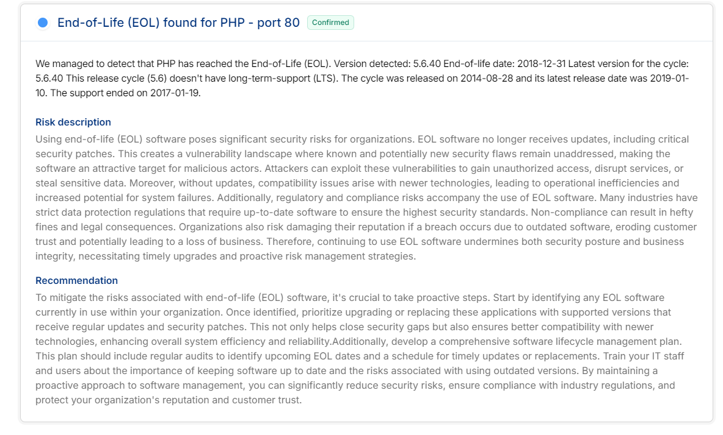

b. End-of-Life (EOL) found for Nginx - port 80: -

Explanation: However, the nginx 1.19.0 reached its End of Life, so it no longer receives security patches and updates. The reason why your system is vulnerable is because known and new security issues are unresolved using EOL software. While these vulnerabilities can be exploited by hackers. Additionally, the outdated software may not be compatible and creates noncompliance with industry regulations, resulting in hefty fines.

Solution: Change to a supported version of Nginx which regularly updates and receives security patches. Apply a software life learning management plan to monitor and refresh the software that is about to expire. Audit your systems regularly to ensure you have no outdated software, reducing the risk of security, and compliance risk.

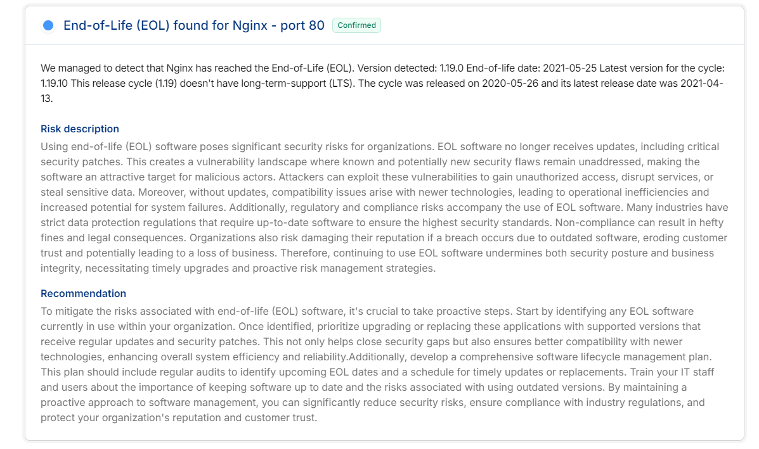

**Using Manual methods for cross verification**

1. **using Nmap: -**

We use the following commands to scan and gain information

Like IP address, Ports and their status (like open) and protocols (like tcp), DNS server address, etc.

1. nmap -sS -p- -T4 -A 192.01.05.73

2. nmap --script vuln -p 80 192.01.05.73

**b. using metasploit:-**

1. use auxiliary/scanner/portscan/tcp

2. set RHOSTS 192.168.56.103

set PORTS 22,25,80,110,21

3. set THREADS 3

Run

4. db_nmap -sV -p 25,80,22 192.168.56.103

These commnads are used for information gathering and exploit finding

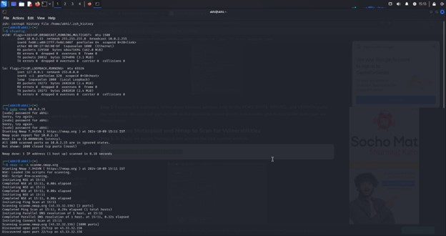

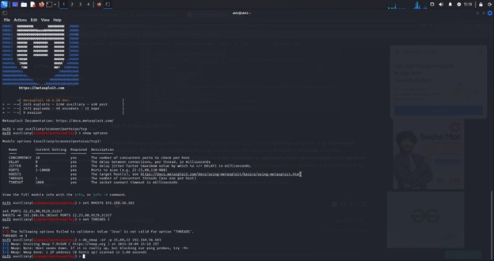

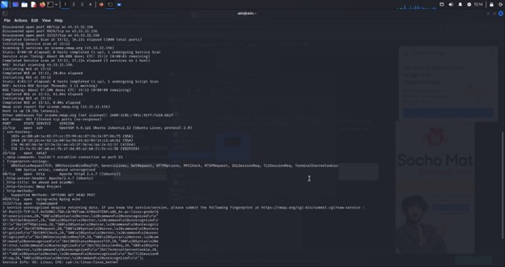

**8.Non-Technical Summary**

During the security assessment of both the Windows and Ubuntu virtual machines, several vulnerabilities were identified that could potentially allow attackers to gain unauthorized access to the systems.

* The Windows VM was found to have a critical vulnerability known as **EternalBlue**, which attackers can use to gain control over the machine. This vulnerability is especially dangerous because it allows attackers to run code remotely without the need for user interaction.
* The **Ubuntu VM** was discovered to be running an outdated version of **OpenSSH**, a common tool for remote administration. This outdated version has known vulnerabilities that could be exploited to gain root access, which would allow an attacker complete control over the system.

**9.Recommended Actions**

1. **Patch the Windows VM** to close the EternalBlue vulnerability by updating the system and applying the latest security patches.
2. **Update the OpenSSH version** on the Ubuntu VM to a secure version that is not vulnerable to the identified exploits.
3. **Implement stricter access controls** for services like RDP and SSH, such as limiting the IP addresses that are allowed to connect and enabling two-factor authentication.

**10.Conclusion**

The penetration test revealed critical vulnerabilities in both the Windows and Ubuntu VMs. The Windows VM is at risk of a well-known exploit that could be used to completely compromise the system, while the Ubuntu VM’s outdated software presents a risk of privilege escalation. Immediate action should be taken to patch these vulnerabilities and secure the services running on the VMs.